Circuit Design of Load Cell Transducer



By
Amr Ashraf
Marwan Ahmed
Khaled Ashraf
Ahmed Abdel Sattar

Contents
Introduction: 3
Output voltage: 3
Determine Excitation Voltage (Vexc​): 3
Find Gain (G): 3
Calculate Change in Resistance (ΔR): 3
Determine Initial Resistance (R): 3
Apply the Formula: 3
Types of Load Cells: 4
Compression Load Cells: 4
Tension Load Cells: 4
Shear Load Cells: 4
Bending Beam Load Cells: 5
S-Beam Load Cells: 5
Canister Load Cells: 5
Block Diagram: 6
Acquiring the raw signal: 7
Connection: 7
Launch Waveforms Software: 7
Select Instrument: 7
Connect and Run: 7
Export Data: 7
Analysis the raw signal: 8
Choose the filter: 8
LTspice: 9
Build the circuit: 10
Arduino: 11

Introduction:
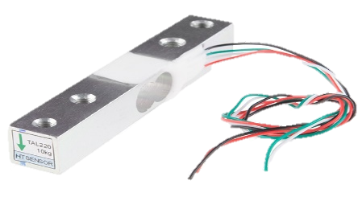
A load cell transducer is a sensor or transducer widely used to convert mechanical forces or loads into electrical signals, playing a crucial role in industrial, manufacturing, and scientific fields where precise force measurement is essential. Operating based on the principle of strain gauge technology, load cells incorporate one or more strain gauges, typically arranged in a Wheatstone bridge configuration, to measure the strain induced by a load. The electrical signal produced by the strain gauges is then converted into a proportional force or weight measurement.

Output voltage:
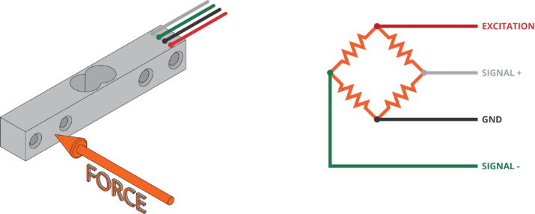
The output voltage of a load cell transducer is typically determined by the strain-induced changes in resistance of the strain gauges within the load cell. Load cells often use Wheatstone bridge configurations of strain gauges, and the output voltage can be calculated based on the bridge's imbalance caused by the applied force.
The formula to calculate the output voltage
(V_{out}) of a load cell in a Wheatstone bridge configuration is:
$$V_{out}=V_{exc}*G*\left(\frac{R}{∆R}\right)$$
To calculate the output voltage (V_{out}​), which represents the output voltage of a load cell transducer, we follow these steps:
Determine Excitation Voltage (V_{exc}​): Identify the excitation voltage applied to the Wheatstone bridge. This voltage is supplied to the load cell to operate the strain gauges.
Find Gain (G): The gain or sensitivity of the load cell is a parameter provided by the manufacturer. It signifies the change in output voltage per unit change in applied force or load.
Calculate Change in Resistance (ΔR): The change in resistance of the strain gauges is linked to the mechanical strain or force applied to the load cell. The specific relationship depends on the type of strain gauges used and the load cell design.
Determine Initial Resistance (R): Identify the initial (unstrained) resistance of the strain gauges. This is a constant value associated with the strain gauges used in the load cell.
Apply the Formula: Substitute the values into the formula to calculate the output voltage.

Types of Load Cells:
Understanding the unique features and applications of each type of load cell is essential for selecting the most suitable one for a given industrial or scientific task. These devices contribute significantly to processes that require accurate and reliable force and weight measurements, ensuring efficiency and safety across various industries.
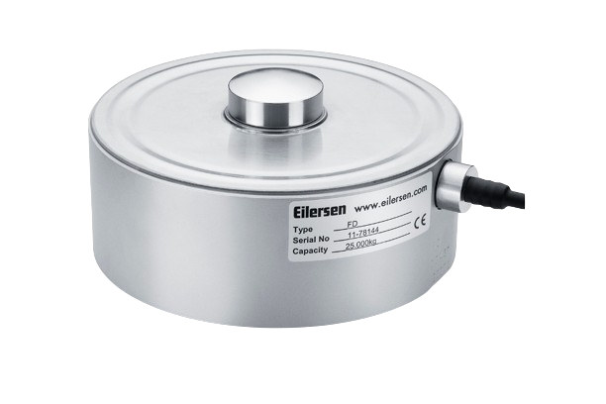
Compression Load Cells:
Description:
Compression load cells are robust devices designed to measure forces pushing or compressing the load cell. They often feature a cylindrical or block-shaped design.
Applications:
Industrial Presses in manufacturing, compression load cells are crucial for measuring the force exerted during pressing operations. This ensures precision and control in processes like metal forming or molding and Tank and Silo Weighing used in systems where loads are applied vertically, compression load cells find application in measuring the weight of tanks or silos in industries such as agriculture and chemical processing.
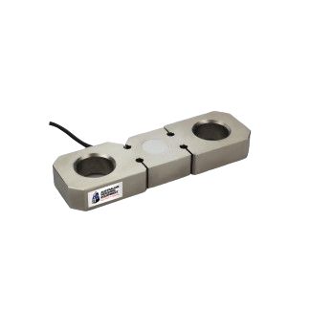
Tension Load Cells:
Description:
Tension load cells are elongated devices specifically built to measure forces pulling or tensile loads. They are designed to withstand tension forces.
Applications:
Crane Scales in the construction and logistics industries, tension load cells are employed in crane scales to accurately measure the load lifted by cranes or hoists. This ensures safe lifting operations and Tensile Testing Machines tension load cells play a crucial role in material testing machines, where they measure the tensile strength of materials. This is essential in material research and quality control.
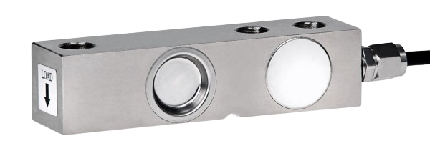
Shear Load Cells:
Description:
Shear load cells are compact devices designed to measure forces applied parallel to the surface of the load cell. They often have a low profile and are suitable for applications with limited space.
Applications:
Material Testing in material testing applications, shear load cells are utilized to precisely measure shear forces. This is critical in assessing the structural integrity and performance of materials under various conditions.
Bending Beam Load Cells:
Description:
Bending beam load cells utilize bending elements to measure loads. They have a simple and versatile design, making them suitable for various industrial weighing applications.
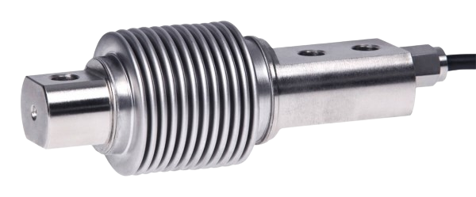
Applications:
Platform Scales bending beam load cells are commonly used in platform scales and floor scales for industrial weighing. They provide accurate and reliable weight measurements for materials on the production floor and Hopper and Tank Weighing in processes involving the storage and dispensing of materials, bending beam load cells are employed to measure the weight of
hoppers and tanks. This ensures precise control over material quantities.
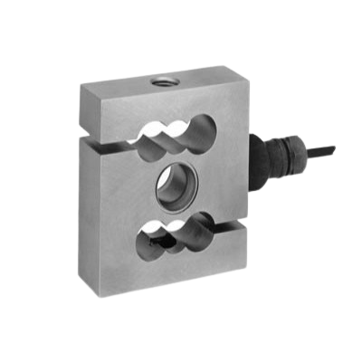
S-Beam Load Cells:
Description:
S-beam load cells feature an S-shaped design, offering versatility for both tension and compression loads. They are widely used in force measurement applications.
Applications:
Tension and Compression Testing S-beam load cells find application in scenarios where the direction of the force may vary. They are used in testing machines and systems where flexibility in force measurement is required.
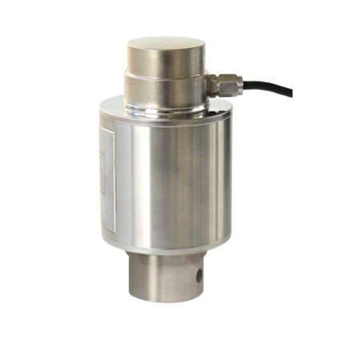
Canister Load Cells:
Description:
Canister load cells are compact and cylindrical, designed to handle high-capacity loads. Their structure allows them to provide accurate measurements in constrained spaces.
Applications:
Heavy Industrial Equipment canister load cells are employed in heavy industrial equipment, such as hydraulic presses and forging machines.
They accurately measure the force applied in these high-capacity processes.

Block Diagram:
Low Pass Filter
low-pass filter: to allow low-frequency signals pass through while attenuating higher frequencies.
Amplifier: Use to amplify the signal from the Load Cell sensor. This amplifier provides high input impedance, which prevents loading of the sensor and ensures accurate signal transfer.

Load Cell Signal

Amplifier

Output Signal

Acquiring the raw signal:
Acquiring the raw signal from a sensor using the Analog Discovery 2 involves connecting the sensor to the device's analog input channels.

Connection:
Connect the sensor output to one of the Analog Discovery 2's analog input channels using appropriate cables and connectors.

Launch Waveforms Software:
Open the Waveforms software on your computer. This software is provided by Diligent for use with the Analog Discovery 2.

Select Instrument:
In Waveforms, select the Instrument Panel and choose the Scope instrument. Configure the settings such as voltage range, time scale.

Connect and Run:
Click "Run" in Waveforms to start acquiring data. The software will display real-time measurements of the raw sensor signal on the oscilloscope interface.

Export Data:
Export the acquired raw signal data (with headers and without headers) for further analysis or processing in external tools or software like LTspice.

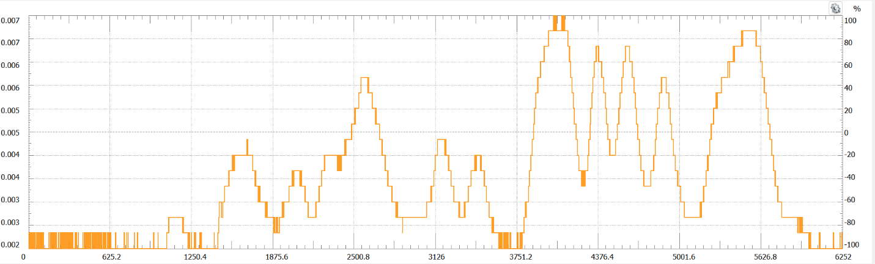

Analysis the raw signal:
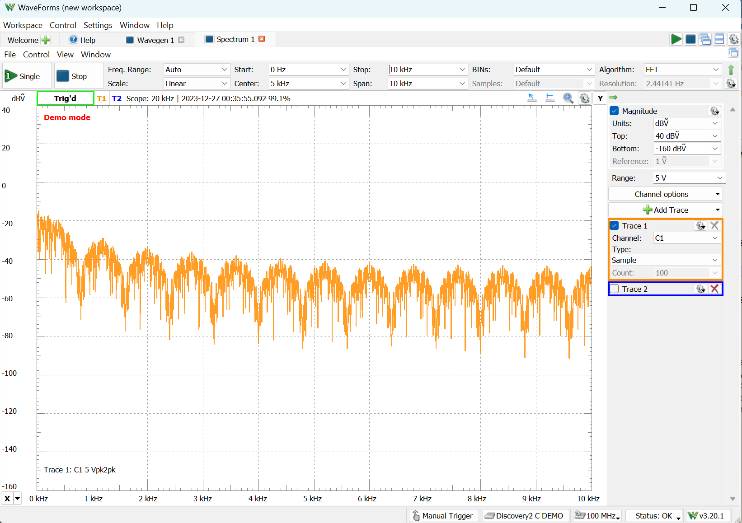
To analyze the raw signal acquired from a sensor involves examining its characteristics to extract relevant information. We should employ techniques such as Fourier analysis to convert the signal from the time domain to the frequency domain. Then we apply filtering techniques, such as low-pass, high-pass, or band-pass filters, to isolate specific frequency components or remove unwanted noise from the raw signal. In our Input Signal this is the frequency domain, then we reduce the frequency until we reach the cut off frequency which is 25 rad/sec in our case.

Choose the filter:
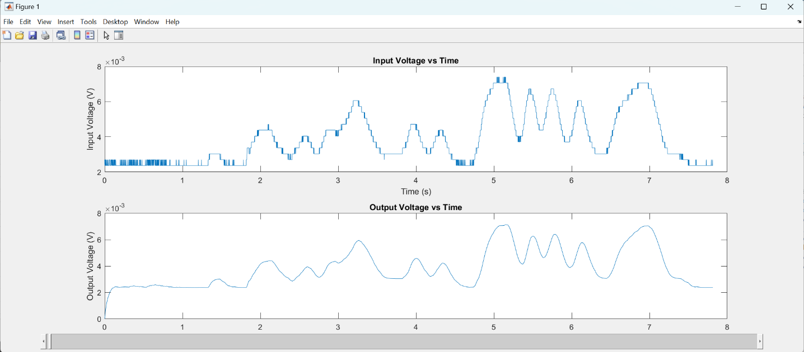
Our goal is to allow low-frequency components to pass through while attenuating or blocking high-frequency components, and we need to amplify the signal. Therefore, our choice will be an active low-pass filter, and we will design it. we used a simple mat-lap script to see the output signal in terms of different omegas to choose the smoothest one which is the same result 25 rad/sec. we can change the omega from the bottom scroll bar.
The circuit: we then calculated the circuit components in terms of our available components in the lab as following
1- we chose R_{i1} as 33k
2- we choose R_{f1} as 33k
3- we choose the omega as 25 rad/sec
4- we calculated the C_{f} = 1 / (W*R_{f1})
5- we choose the gain as 150
6- we choose the R_{i2} = 33k
7- we choose R_{f2} = 4.95M to make a 150 gain
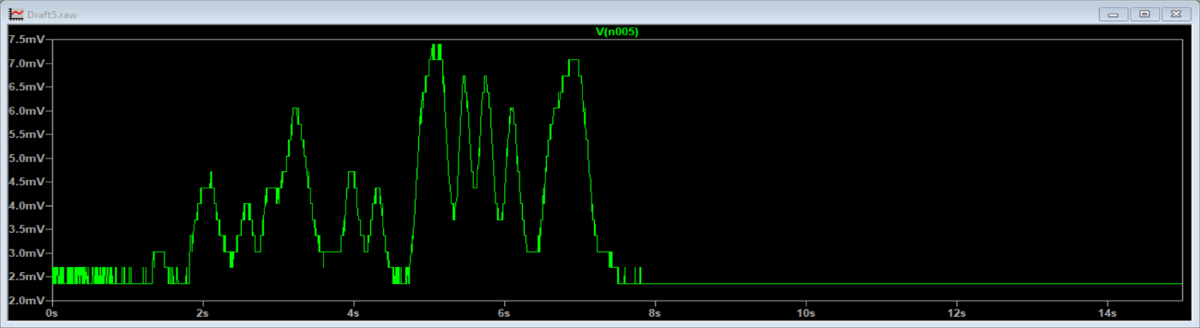
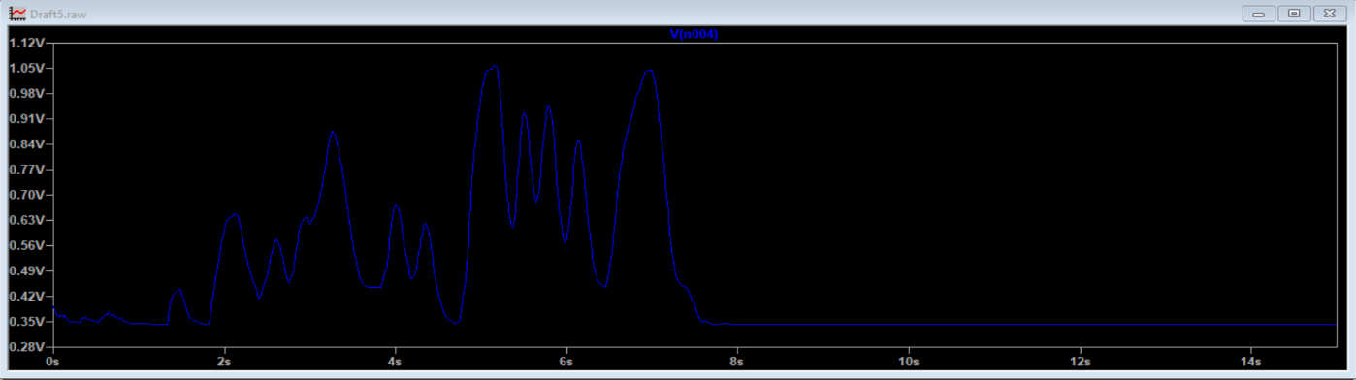
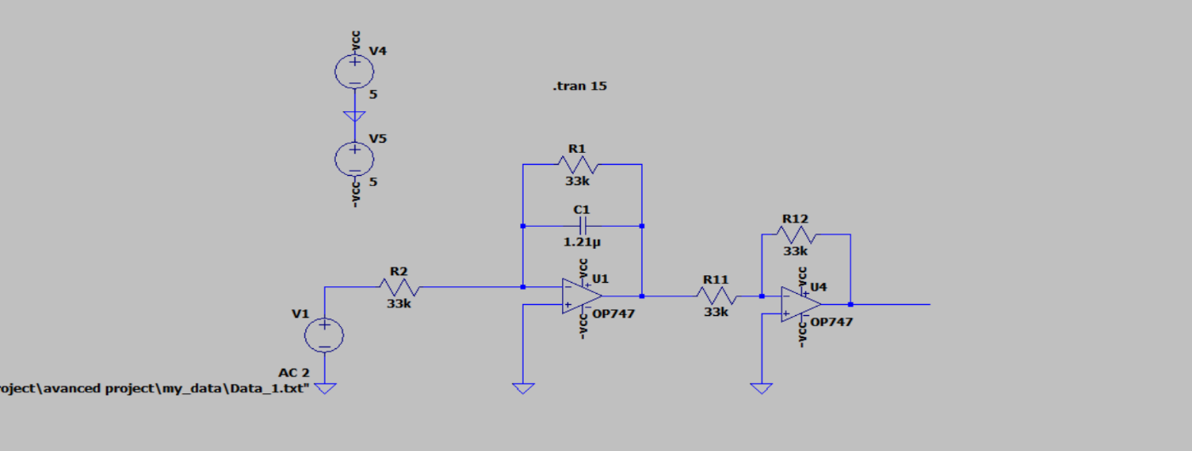
LTspice: Now, we begin designing the circuit in LTspice, importing the raw signal, and measuring the output. The green signal represents the raw input, while the blue signal signifies the filtered output. Notably, the filtered signal exhibits increased amplitude, and a significant reduction in noise is observed.

Build the circuit:
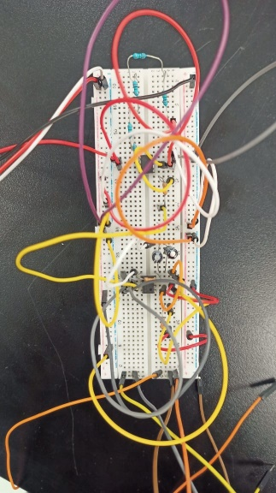
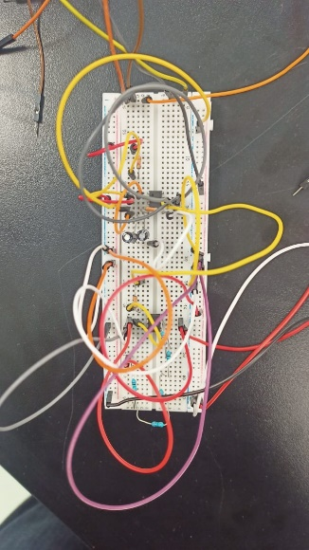
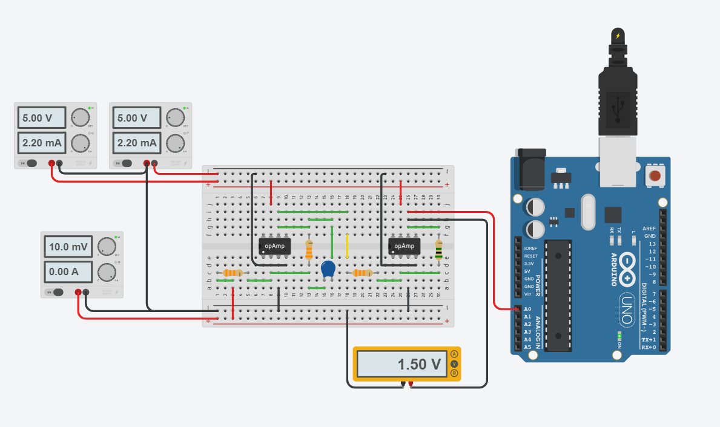
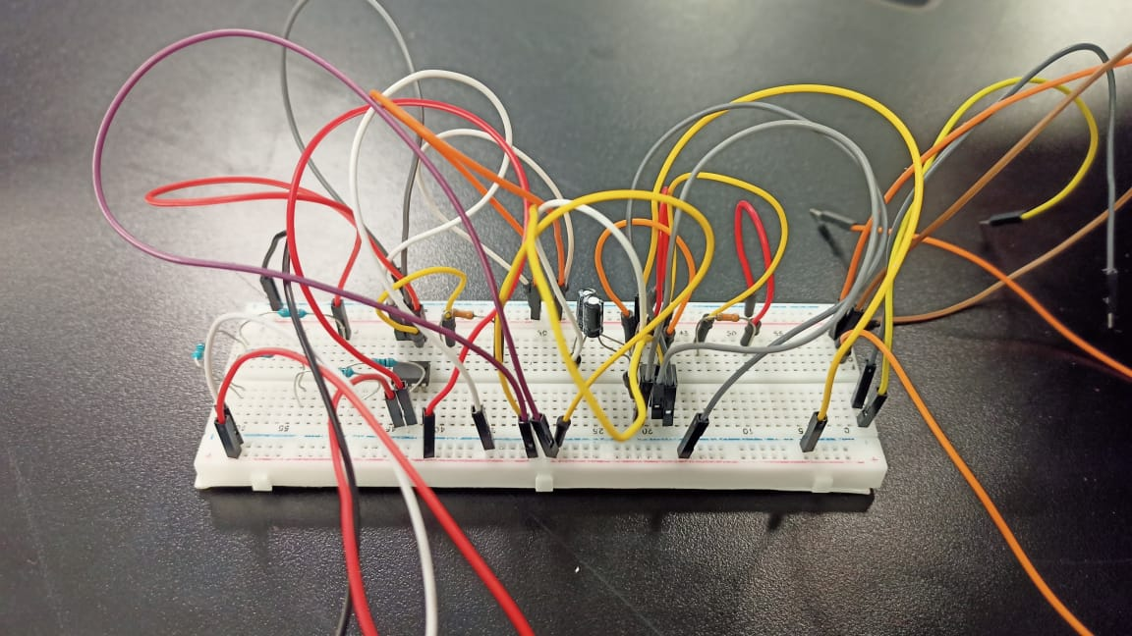
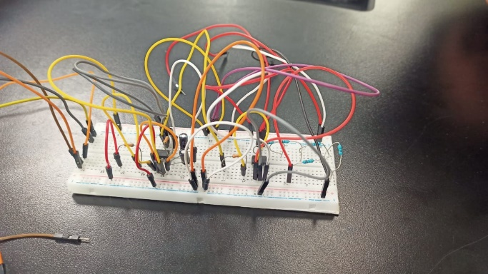
We first designed it on tinker cad software so it becomes easy for us to implement it with real hardware and reduce the errors as possible, we also tried our best to make it look clean and prevent wire crossing each other, we also used to know color for +Vcc or any positive signal and -Vcc or any negative signal as red and black colors

Arduino:
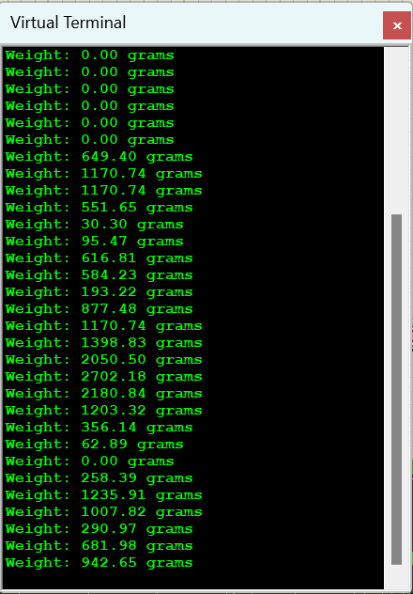
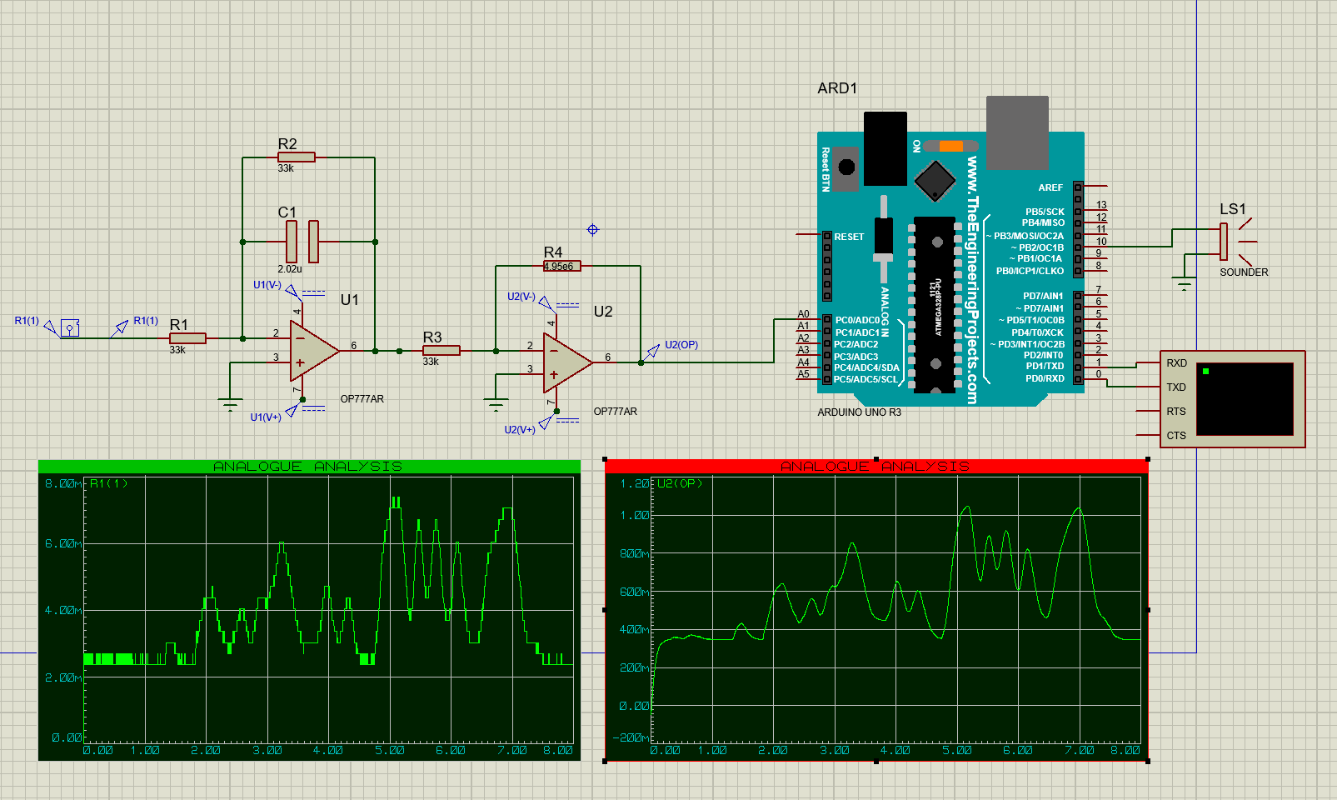
After that we downloaded a new software Proteus 8 so we can simulate an Arduino, it wasn’t easy because it wasn’t built in it so we added it from external source as new library and we designed the circuit and then add the output signal to the A0 port and then we read the analog port in the code to measure the weight based on the input signal so we made our load cell works as a weight measure

